


Graduation Project
Haneedy – E-commerce Website for Handmade Products
React Frontend Web Developer
(SHR3_SWD2_S1)
Made by
Mahmoud Ibrahim Elsayed Sobhi
Mohamed Gomaa Elshahat Metwally
Hashim Elsayed Hashim Eltilaty
Mohamed Emad AbdAlazeam Ali
Mohamed Ali El Sayed Ali
Mohamed Mahmoud Esmail Gohary

Supervised by
Eng. Ahmed Hatem

Table of Contents
- Introduction
- Project Overview
- Technologies and Dependencies
- Folder Structure
- Context Providers
- Routing Architecture
- Components
  - 7.1 App.js
  - 7.2 index.js
  - 7.3 AllHome.js
  - 7.4 AllShop.js
  - 7.5 AllShopCart.js
  - 7.6 AllSingleProduct.js
  - 7.7 Favorites.js
  - 7.8 AllCheckout.js
  - 7.9 AllContact.js
- Cart and Wishlist Functionality
- Styling and Responsiveness
- How to Run the Project
- Future Enhancements
- Screenshots (Placeholders)
- Conclusion

1. Introduction
This documentation provides a detailed explanation of the Haneedy E-Commerce Website project. It includes an overview of the project, structure, components, code explanations, and how to run the application.

2. Project Overview
Haneedy is an e-commerce platform for handmade products. Users can browse products, view detailed product pages, add items to their cart, manage wishlist, and proceed to checkout.

3. Technologies and Dependencies
- React 18+
- react-router 6+
- react-use-cart
- Bootstrap 5
- Bootstrap Icons
- FontAwesome Icons

4. Folder Structure
/src
/Components
AllCompo.js
Footer.js
/Context
FavoritesContext.js
/Data
AllData.js
/Home
AllHome.js
/Shop
AllShop.js
/ShopCart
AllShopCart.js
/SingleProduct
AllSingleProduct.js
/Checkout
AllCheckout.js
/Contact
AllContact.js
/ShopFavorites
Favorites.js
App.js
index.js

5. Context Providers

AllData.js
This context provides all product data to the application.
import React, { createContext } from 'react';
export const apiValue = createContext([]);
export const AllData = ({ children }) => {
const products = [/* Array of product objects */];
return <apiValue.Provider value={products}>{children}</apiValue.Provider>;
};

FavoritesContext.js
Manages user wishlist.
import React, { createContext, useState, useContext } from 'react';
export const FavoritesContext = createContext();
export const useFavorites = () => useContext(FavoritesContext);
export const FavoritesProvider = ({ children }) => {
const [favorites, setFavorites] = useState([]);
const addToFavorites = (product) => setFavorites([...favorites, product]);
const removeFromFavorites = (id) => setFavorites(favorites.filter(p => p.id !== id));
return (
<FavoritesContext.Provider value={{ favorites, addToFavorites, removeFromFavorites }}>
{children}
</FavoritesContext.Provider>
);
};

6. Routing Architecture
Uses React Router’s createBrowserRouter:
let router = createBrowserRouter([
{ path: '/', element: <App /> },
{ path: 'shop', element: <AllShop /> },
{ path: 'contact', element: <AllContact /> },
{ path: 'checkout', element: <AllCheckout /> },
{ path: 'shopcart', element: <AllShopCart /> },
{ path: 'singleproduct/:id', element: <AllSingleProduct /> },
{ path: 'shopfavorites', element: <Favorites /> },
]);
ReactDOM.createRoot(document.getElementById('root')).render(
<AllData>
<FavoritesProvider>
<CartProvider>
<RouterProvider router={router} />
</CartProvider>
</FavoritesProvider>
</AllData>
);

7. Components

7.1 App.js
Main entry component displaying the homepage.
function App() {
return (
<div>
<AllCompo />
<AllHome />
<Footer />
</div>
);
}

7.2 index.js
1  2  3  4  5  6  7  8  9  10  11  12  13  14  15  16  17  18  19  20  21  22  23  24  25  26  27  28  29  30  31  32  33  34  35  36  37  38  39  40  41  42  43  44  45  46  47  48  49  50  51  52  53  54  55 | import ReactDOM from "react-dom/client";  import App from "./App";  import { AllData } from "./Data/AllData";  import { createBrowserRouter, RouterProvider } from "react-router";  import AllShop from "./Shop/AllShop";  import AllContact from "./Contact/AllContact";  import AllCheckout from "./Checkout/AllCheckout";  import AllShopCart from "./ShopCart/AllShopCart";  import AllSingleProduct from "./SingleProduct/AllSingleProduct";  import { CartProvider } from "react-use-cart";  import "bootstrap-icons/font/bootstrap-icons.css";  import { FavoritesProvider } from "./context/FavoritesContext";  import Favorites from "./ShopFavorites/Favorites";  let router = createBrowserRouter([  {  path: "/",  element: <App />,  },  {  path: "shop",  element: <AllShop />,  },  {  path: "contact",  element: <AllContact />,  },  {  path: "checkout",  element: <AllCheckout />,  },  {  path: "shopcart",  element: <AllShopCart />,  },  {  path: "singleproduct/:id",  element: <AllSingleProduct />,  },  {  path: "shopfavorites",  element: <Favorites />,  },  ]);  ReactDOM.createRoot(document.getElementById("root")).render(  <AllData>  <FavoritesProvider>  <CartProvider>  <RouterProvider router={router} />  </CartProvider>  </FavoritesProvider>  </AllData>  );

7.3 AllHome.js
1  2  3  4  5  6  7  8  9  10  11  12  13  14  15  16  17  18  19  20  21  22  23  24  25  26  27  28  29  30  31  32  33  34  35  36  37  38  39  40  41  42  43  44  45  46  47  48  49  50  51  52  53  54  55  56  57  58  59  60  61  62  63  64  65  66  67  68  69  70  71  72  73  74  75  76  77  78  79  80  81  82  83  84  85  86  87  88  89  90  91  92  93  94  95  96  97  98  99  100  101  102  103  104  105  106  107  108  109  110  111  112  113  114  115  116  117  118  119  120  121  122  123  124  125  126  127  128  129  130  131  132  133  134  135  136  137  138  139  140  141  142  143  144  145  146  147  148  149  150  151  152  153  154  155  156  157  158  159  160  161  162  163  164  165  166  167  168  169  170  171  172  173  174  175  176  177  178  179  180  181  182  183  184  185  186  187  188  189  190  191  192  193  194  195  196  197  198  199  200  201  202  203  204  205  206  207  208  209  210  211  212  213  214  215  216  217  218  219  220  221  222  223  224  225  226  227  228  229  230  231  232  233  234  235  236  237  238  239  240  241  242  243  244  245  246  247  248  249  250  251  252  253  254  255  256  257  258  259  260  261  262  263  264  265  266  267  268  269  270  271  272  273  274  275  276  277  278  279  280  281  282  283  284  285  286  287  288  289  290  291  292  293  294  295  296  297  298  299  300  301  302  303  304  305  306  307  308  309  310  311  312  313  314  315  316  317  318  319  320  321  322  323  324  325  326  327  328  329  330  331  332  333  334  335  336  337  338  339  340  341  342  343  344  345  346  347  348  349  350  351  352  353  354  355  356  357  358  359  360  361  362  363  364  365  366  367  368  369  370  371  372  373  374  375  376  377  378  379  380  381  382  383  384  385  386  387  388  389  390  391  392  393  394  395  396  397  398  399  400  401  402  403  404  405  406  407  408  409  410  411  412  413  414  415  416  417  418  419  420  421  422  423  424  425  426  427  428  429  430  431  432  433  434  435  436  437  438  439  440  441  442  443  444  445  446  447  448  449  450  451  452  453  454  455  456  457  458  459  460  461  462  463  464  465  466  467  468  469  470  471  472  473  474  475  476  477  478  479  480  481  482  483  484  485  486  487  488  489  490  491  492  493  494  495  496  497  498  499  500  501  502  503  504  505  506 | import React from "react";  import { Link } from "react-router-dom";  import OwlCarousel from "react-owl-carousel";  import "owl.carousel/dist/assets/owl.carousel.css";  import "owl.carousel/dist/assets/owl.theme.default.css";  function AllHome() {  return (  <>  {/* Carousel Start */}  <div className="container-fluid mb-3">  <div className="row px-xl-5">  <div className="col-lg-8">  <div  id="header-carousel"  className="carousel slide carousel-fade mb-30 mb-lg-0"  data-ride="carousel"  >  <ol className="carousel-indicators">  <li  data-target="#header-carousel"  data-slide-to={0}  className="active"  />  <li data-target="#header-carousel" data-slide-to={1} />  <li data-target="#header-carousel" data-slide-to={2} />  </ol>  <div className="carousel-inner">  <div  className="carousel-item position-relative active"  style={{ height: 430 }}  >  <img  className="position-absolute w-100 h-100"  src="img/carousel-1.jpg"  style={{ objectFit: "cover" }}  />  <div className="carousel-caption d-flex flex-column align-items-center justify-content-center">  <div className="p-3" style={{ maxWidth: 700 }}>  <h1 className="display-4 text-white mb-3 animate__animated animate__fadeInDown">  Handmade Crafts  </h1>  <p className="mx-md-5 px-5 animate__animated animate__bounceIn">  Discover unique, handcrafted products made with love and  creativity.  </p>  <Link  to="/shop"  className="btn btn-outline-light py-2 px-4 mt-3 animate__animated animate__fadeInUp"  >  Shop Now  </Link>  </div>  </div>  </div>  <div  className="carousel-item position-relative"  style={{ height: 430 }}  >  <img  className="position-absolute w-100 h-100"  src="img/carousel-2.jpg"  style={{ objectFit: "cover" }}  />  <div className="carousel-caption d-flex flex-column align-items-center justify-content-center">  <div className="p-3" style={{ maxWidth: 700 }}>  <h1 className="display-4 text-white mb-3 animate__animated animate__fadeInDown">  Women Fashion  </h1>  <p className="mx-md-5 px-5 animate__animated animate__bounceIn">  Explore our collection of beautiful handmade accessories  and clothing crafted for women.  </p>  <Link  to="/shop"  className="btn btn-outline-light py-2 px-4 mt-3 animate__animated animate__fadeInUp"  >  Shop Now  </Link>  </div>  </div>  </div>  <div  className="carousel-item position-relative"  style={{ height: 430 }}  >  <img  className="position-absolute w-100 h-100"  src="img/carousel-3.jpg"  style={{ objectFit: "cover" }}  />  <div className="carousel-caption d-flex flex-column align-items-center justify-content-center">  <div className="p-3" style={{ maxWidth: 700 }}>  <h1 className="display-4 text-white mb-3 animate__animated animate__fadeInDown">  Kids Fashion  </h1>  <p className="mx-md-5 px-5 animate__animated animate__bounceIn">  Find unique, handcrafted toys and clothing designed  specially for kids.  </p>  <Link  to="/shop"  className="btn btn-outline-light py-2 px-4 mt-3 animate__animated animate__fadeInUp"  >  Shop Now  </Link>  </div>  </div>  </div>  </div>  </div>  </div>  <div className="col-lg-4">  <div className="product-offer mb-30" style={{ height: 200 }}>  <img className="img-fluid" src="img/offer-1.jpg" alt="" />  <div className="offer-text">  <h6 className="text-white text-uppercase">Save 20%</h6>  <h3 className="text-white mb-3">Special Offer</h3>  <Link to="/shop" className="btn btn-primary">  Shop Now  </Link>  </div>  </div>  <div className="product-offer mb-30" style={{ height: 200 }}>  <img className="img-fluid" src="img/offer-2.jpg" alt="" />  <div className="offer-text">  <h6 className="text-white text-uppercase">Save 20%</h6>  <h3 className="text-white mb-3">Special Offer</h3>  <Link to="/shop" className="btn btn-primary">  Shop Now  </Link>  </div>  </div>  </div>  </div>  </div>  {/* Carousel End */}  {/* Featured Start */}  <div className="container-fluid pt-5">  <div className="row px-xl-5 pb-3">  <div className="col-lg-3 col-md-6 col-sm-12 pb-1">  <div  className="d-flex align-items-center bg-light mb-4"  style={{ padding: 30 }}  >  <h1 className="fa fa-check text-primary m-0 mr-3" />  <h5 className="font-weight-semi-bold m-0">Quality Product</h5>  </div>  </div>  <div className="col-lg-3 col-md-6 col-sm-12 pb-1">  <div  className="d-flex align-items-center bg-light mb-4"  style={{ padding: 30 }}  >  <h1 className="fa fa-shipping-fast text-primary m-0 mr-2" />  <h5 className="font-weight-semi-bold m-0">Low-Cost Shipping</h5>  </div>  </div>  <div className="col-lg-3 col-md-6 col-sm-12 pb-1">  <div  className="d-flex align-items-center bg-light mb-4"  style={{ padding: 30 }}  >  <h1 className="fas fa-exchange-alt text-primary m-0 mr-3" />  <h5 className="font-weight-semi-bold m-0">14-Day Return</h5>  </div>  </div>  <div className="col-lg-3 col-md-6 col-sm-12 pb-1">  <div  className="d-flex align-items-center bg-light mb-4"  style={{ padding: 30 }}  >  <h1 className="fa fa-phone-volume text-primary m-0 mr-3" />  <h5 className="font-weight-semi-bold m-0">24/7 Support</h5>  </div>  </div>  </div>  </div>  {/* Featured End */}  {/* Products Start */}  <div className="container-fluid pt-5 pb-3">  <h2 className="section-title position-relative text-uppercase mx-xl-5 mb-4">  <span className="bg-secondary pr-3">Recent Products</span>  </h2>  <div className="row px-xl-5">  <div className="col-lg-3 col-md-4 col-sm-6 pb-1">  <div className="product-item bg-light mb-4">  <div className="product-img position-relative overflow-hidden">  <img  className="img-fluid w-100"  src="https://handmade.com/media-library/image.jpg?id=60011203&width=400"  alt=""  />  </div>  <div className="text-center py-4">  <a  className="h6 text-decoration-none text-truncate"  href="/shop"  >  Product Name Goes Here  </a>  <div className="d-flex align-items-center justify-content-center mt-2">  <h5>$123.00</h5>  <h6 className="text-muted ml-2">  <del>$123.00</del>  </h6>  </div>  <div className="d-flex align-items-center justify-content-center mb-1">  <small className="fa fa-star text-primary mr-1" />  <small className="fa fa-star text-primary mr-1" />  <small className="fa fa-star text-primary mr-1" />  <small className="fa fa-star text-primary mr-1" />  <small className="fa fa-star text-primary mr-1" />  <small>(5)</small>  </div>  </div>  </div>  </div>  <div className="col-lg-3 col-md-4 col-sm-6 pb-1">  <div className="product-item bg-light mb-4">  <div className="product-img position-relative overflow-hidden">  <img  className="img-fluid w-100"  src="https://handmade.com/media-library/image.jpg?id=60011203&width=400"  alt=""  />  </div>  <div className="text-center py-4">  <a  className="h6 text-decoration-none text-truncate"  href="/shop"  >  Product Name Goes Here  </a>  <div className="d-flex align-items-center justify-content-center mt-2">  <h5>$123.00</h5>  <h6 className="text-muted ml-2">  <del>$123.00</del>  </h6>  </div>  <div className="d-flex align-items-center justify-content-center mb-1">  <small className="fa fa-star text-primary mr-1" />  <small className="fa fa-star text-primary mr-1" />  <small className="fa fa-star text-primary mr-1" />  <small className="fa fa-star text-primary mr-1" />  <small className="fa fa-star text-primary mr-1" />  <small>(5)</small>  </div>  </div>  </div>  </div>  <div className="col-lg-3 col-md-4 col-sm-6 pb-1">  <div className="product-item bg-light mb-4">  <div className="product-img position-relative overflow-hidden">  <img  className="img-fluid w-100"  src="https://handmade.com/media-library/image.jpg?id=60011203&width=400"  alt=""  />  </div>  <div className="text-center py-4">  <a  className="h6 text-decoration-none text-truncate"  href="/shop"  >  Product Name Goes Here  </a>  <div className="d-flex align-items-center justify-content-center mt-2">  <h5>$123.00</h5>  <h6 className="text-muted ml-2">  <del>$123.00</del>  </h6>  </div>  <div className="d-flex align-items-center justify-content-center mb-1">  <small className="fa fa-star text-primary mr-1" />  <small className="fa fa-star text-primary mr-1" />  <small className="fa fa-star text-primary mr-1" />  <small className="fa fa-star text-primary mr-1" />  <small className="fa fa-star text-primary mr-1" />  <small>(5)</small>  </div>  </div>  </div>  </div>  <div className="col-lg-3 col-md-4 col-sm-6 pb-1">  <div className="product-item bg-light mb-4">  <div className="product-img position-relative overflow-hidden">  <img  className="img-fluid w-100"  src="https://handmade.com/media-library/image.jpg?id=60011203&width=400"  alt=""  />  </div>  <div className="text-center py-4">  <a  className="h6 text-decoration-none text-truncate"  href="/shop"  >  Product Name Goes Here  </a>  <div className="d-flex align-items-center justify-content-center mt-2">  <h5>$123.00</h5>  <h6 className="text-muted ml-2">  <del>$123.00</del>  </h6>  </div>  <div className="d-flex align-items-center justify-content-center mb-1">  <small className="fa fa-star text-primary mr-1" />  <small className="fa fa-star text-primary mr-1" />  <small className="fa fa-star text-primary mr-1" />  <small className="fa fa-star text-primary mr-1" />  <small className="fa fa-star text-primary mr-1" />  <small>(5)</small>  </div>  </div>  </div>  </div>  <div className="col-lg-3 col-md-4 col-sm-6 pb-1">  <div className="product-item bg-light mb-4">  <div className="product-img position-relative overflow-hidden">  <img  className="img-fluid w-100"  src="https://handmade.com/media-library/image.jpg?id=60011203&width=400"  alt=""  />  </div>  <div className="text-center py-4">  <a  className="h6 text-decoration-none text-truncate"  href="/shop"  >  Product Name Goes Here  </a>  <div className="d-flex align-items-center justify-content-center mt-2">  <h5>$123.00</h5>  <h6 className="text-muted ml-2">  <del>$123.00</del>  </h6>  </div>  <div className="d-flex align-items-center justify-content-center mb-1">  <small className="fa fa-star text-primary mr-1" />  <small className="fa fa-star text-primary mr-1" />  <small className="fa fa-star text-primary mr-1" />  <small className="fa fa-star text-primary mr-1" />  <small className="fa fa-star text-primary mr-1" />  <small>(5)</small>  </div>  </div>  </div>  </div>  <div className="col-lg-3 col-md-4 col-sm-6 pb-1">  <div className="product-item bg-light mb-4">  <div className="product-img position-relative overflow-hidden">  <img  className="img-fluid w-100"  src="https://handmade.com/media-library/image.jpg?id=60011203&width=400"  alt=""  />  </div>  <div className="text-center py-4">  <a  className="h6 text-decoration-none text-truncate"  href="/shop"  >  Product Name Goes Here  </a>  <div className="d-flex align-items-center justify-content-center mt-2">  <h5>$123.00</h5>  <h6 className="text-muted ml-2">  <del>$123.00</del>  </h6>  </div>  <div className="d-flex align-items-center justify-content-center mb-1">  <small className="fa fa-star text-primary mr-1" />  <small className="fa fa-star text-primary mr-1" />  <small className="fa fa-star text-primary mr-1" />  <small className="fa fa-star text-primary mr-1" />  <small className="fa fa-star text-primary mr-1" />  <small>(5)</small>  </div>  </div>  </div>  </div>  <div className="col-lg-3 col-md-4 col-sm-6 pb-1">  <div className="product-item bg-light mb-4">  <div className="product-img position-relative overflow-hidden">  <img  className="img-fluid w-100"  src="https://handmade.com/media-library/image.jpg?id=60011203&width=400"  alt=""  />  </div>  <div className="text-center py-4">  <a  className="h6 text-decoration-none text-truncate"  href=" /shop"  >  Product Name Goes Here  </a>  <div className="d-flex align-items-center justify-content-center mt-2">  <h5>$123.00</h5>  <h6 className="text-muted ml-2">  <del>$123.00</del>  </h6>  </div>  <div className="d-flex align-items-center justify-content-center mb-1">  <small className="fa fa-star text-primary mr-1" />  <small className="fa fa-star text-primary mr-1" />  <small className="fa fa-star text-primary mr-1" />  <small className="fa fa-star text-primary mr-1" />  <small className="fa fa-star text-primary mr-1" />  <small>(5)</small>  </div>  </div>  </div>  </div>  <div className="col-lg-3 col-md-4 col-sm-6 pb-1">  <div className="product-item bg-light mb-4">  <div className="product-img position-relative overflow-hidden">  <img  className="img-fluid w-100"  src="https://handmade.com/media-library/image.jpg?id=60011203&width=400"  alt=""  />  </div>  <div className="text-center py-4">  <a  className="h6 text-decoration-none text-truncate"  href="/shop"  >  Product Name Goes Here  </a>  <div className="d-flex align-items-center justify-content-center mt-2">  <h5>$123.00</h5>  <h6 className="text-muted ml-2">  <del>$123.00</del>  </h6>  </div>  <div className="d-flex align-items-center justify-content-center mb-1">  <small className="fa fa-star text-primary mr-1" />  <small className="fa fa-star text-primary mr-1" />  <small className="fa fa-star text-primary mr-1" />  <small className="fa fa-star text-primary mr-1" />  <small className="fa fa-star text-primary mr-1" />  <small>(5)</small>  </div>  </div>  </div>  </div>  </div>  </div>  {/* Products End */}  {/* Vendor Start */}  <div className="container-fluid py-5">  <div className="row px-xl-5">  <div className="col">  <OwlCarousel  className="owl-carousel vendor-carousel "  items="6"  loop  dots={false}  responsive={{  0: { items: 2 },  576: { items: 3 },  768: { items: 4 },  52: { items: 5 },  1200: { items: 6 },  }}  >  <div className="bg-light p-4">  <img src="img/vendor-1.jpg" alt="" />  </div>  <div className="bg-light p-4">  <img src="img/vendor-2.jpg" alt="" />  </div>  <div className="bg-light p-4">  <img src="img/vendor-3.jpg" alt="" />  </div>  <div className="bg-light p-4">  <img src="img/vendor-4.jpg" alt="" />  </div>  <div className="bg-light p-4">  <img src="img/vendor-5.jpg" alt="" />  </div>  <div className="bg-light p-4">  <img src="img/vendor-6.jpg" alt="" />  </div>  <div className="bg-light p-4">  <img src="img/vendor-7.jpg" alt="" />  </div>  <div className="bg-light p-4">  <img src="img/vendor-8.jpg" alt="" />  </div>  </OwlCarousel>  </div>  </div>  </div>  {/* Vendor End */}  </>  );  }  export default AllHome;

7.4 AllShop.js
Displays all products.
1  2  3  4  5  6  7  8  9  10  11  12  13  14  15  16  17  18  19  20  21  22  23  24  25  26  27  28  29  30  31  32  33  34  35  36  37  38  39  40  41  42  43  44  45  46  47  48  49  50  51  52  53  54  55  56  57  58  59  60  61  62  63  64  65  66  67  68  69  70  71  72  73  74  75  76  77  78  79  80  81  82  83  84  85  86  87  88  89  90  91  92  93  94  95  96  97  98  99  100  101  102  103  104  105  106  107  108  109  110  111  112  113  114  115  116  117  118  119  120  121  122  123  124  125  126  127  128  129  130  131  132  133  134  135  136  137  138  139  140  141  142  143  144  145  146  147  148  149  150  151  152  153  154  155  156  157  158  159  160  161  162  163  164  165  166  167  168  169  170  171  172  173  174  175  176  177  178  179  180  181  182  183  184  185  186  187  188  189  190  191  192  193  194  195  196  197  198  199  200  201  202  203  204  205  206  207  208  209  210  211  212  213  214  215  216  217  218  219  220  221  222  223  224  225  226  227  228  229  230  231  232  233  234  235  236  237  238  239  240  241  242  243  244  245  246  247  248  249  250  251  252  253  254  255  256  257  258  259  260  261  262  263  264  265  266  267  268  269  270  271  272  273  274  275  276  277  278  279  280  281  282  283  284  285  286  287  288  289  290  291  292  293  294  295  296  297  298  299  300  301  302  303  304  305  306  307  308  309  310  311  312  313  314  315  316  317  318  319  320  321  322  323  324  325  326  327  328  329  330  331  332  333  334  335  336  337  338  339  340  341  342  343  344  345  346  347  348  349  350  351  352  353  354  355  356  357  358  359  360  361  362  363  364  365  366  367  368  369  370  371  372  373  374  375  376  377  378  379  380  381  382  383  384  385  386  387  388  389  390  391  392  393  394  395  396  397  398  399  400  401  402  403  404  405  406  407  408  409  410 | import React, { useContext, useState } from "react";  import AllCompo from "../Components/AllCompo.jsx";  import Footer from "../Components/Footer.jsx";  import { apiValue } from "../Data/AllData.js";  import { Link } from "react-router-dom";  import { useCart } from "react-use-cart";  import { useFavorites } from "../context/FavoritesContext";  function AllShop() {  const data = useContext(apiValue);  // ---------- Filter State ----------  const [priceFilter, setPriceFilter] = useState("ALL");  const filterByPrice = (item) => {  if (priceFilter === "ALL") return true;  const price = item.price;  if (priceFilter === "0-100") return price >= 0 && price <= 100;  if (priceFilter === "100-200") return price >= 100 && price <= 200;  if (priceFilter === "200-300") return price >= 200 && price <= 300;  if (priceFilter === "300-400") return price >= 300 && price <= 400;  if (priceFilter === "400-500") return price >= 400 && price <= 500;  return true;  };  const filteredProducts = data.filter(filterByPrice);  // ---------- Pagination ----------  const [currentPage, setCurrentPage] = useState(1);  const productsPerPage = 9;  const indexOfLast = currentPage * productsPerPage;  const indexOfFirst = indexOfLast - productsPerPage;  const currentProducts = filteredProducts.slice(indexOfFirst, indexOfLast);  const totalPages = Math.ceil(filteredProducts.length / productsPerPage);  const goToPage = (page) => {  if (page < 1 || page > totalPages) return;  setCurrentPage(page);  };  const { addItem } = useCart();  const {  items,  totalItems,  cartTotal,  totalUniqueItems,  updateItemQuantity,  removeItem,  isEmpty,  emptyCart,  } = useCart();  const { favorites, addToFavorites, removeFromFavorites } = useFavorites();  return (  <>  <AllCompo />  {/* Breadcrumb Start */}  <div className="container-fluid">  <div className="row px-xl-5">  <div className="col-12">  <nav className="breadcrumb bg-light mb-30">  <a className="breadcrumb-item text-dark" href="/">  Home  </a>  <span className="breadcrumb-item active">Shop</span>  </nav>  </div>  </div>  </div>  {/* Breadcrumb End */}  {/* Shop Start */}  <div className="container-fluid">  <div className="row px-xl-5">  {/* Shop Sidebar Start */}  <div className="col-lg-3 col-md-4">  {/* Price Filter */}  <h5 className="section-title position-relative text-uppercase mb-3">  <span className="bg-secondary pr-3">Filter by price</span>  </h5>  <div className="bg-light p-4 mb-30">  <form>  {/* ALL */}  <div className="custom-control custom-radio d-flex align-items-center justify-content-between mb-3">  <input  type="radio"  name="price"  className="custom-control-input"  id="price-all"  checked={priceFilter === "ALL"}  onChange={() => {  setPriceFilter("ALL");  setCurrentPage(1);  }}  />  <label className="custom-control-label" htmlFor="price-all">  All Price  </label>  </div>  {/* 0 - 100 */}  <div className="custom-control custom-radio d-flex align-items-center justify-content-between mb-3">  <input  type="radio"  name="price"  className="custom-control-input"  id="price-1"  checked={priceFilter === "0-100"}  onChange={() => {  setPriceFilter("0-100");  setCurrentPage(1);  }}  />  <label className="custom-control-label" htmlFor="price-1">  $0 - $100  </label>  </div>  {/* 100 - 200 */}  <div className="custom-control custom-radio d-flex align-items-center justify-content-between mb-3">  <input  type="radio"  name="price"  className="custom-control-input"  id="price-2"  checked={priceFilter === "100-200"}  onChange={() => {  setPriceFilter("100-200");  setCurrentPage(1);  }}  />  <label className="custom-control-label" htmlFor="price-2">  $100 - $200  </label>  </div>  {/* 200 - 300 */}  <div className="custom-control custom-radio d-flex align-items-center justify-content-between mb-3">  <input  type="radio"  name="price"  className="custom-control-input"  id="price-3"  checked={priceFilter === "200-300"}  onChange={() => {  setPriceFilter("200-300");  setCurrentPage(1);  }}  />  <label className="custom-control-label" htmlFor="price-3">  $200 - $300  </label>  </div>  {/* 300 - 400 */}  <div className="custom-control custom-radio d-flex align-items-center justify-content-between mb-3">  <input  type="radio"  name="price"  className="custom-control-input"  id="price-4"  checked={priceFilter === "300-400"}  onChange={() => {  setPriceFilter("300-400");  setCurrentPage(1);  }}  />  <label className="custom-control-label" htmlFor="price-4">  $300 - $400  </label>  </div>  {/* 400 - 500 */}  <div className="custom-control custom-radio d-flex align-items-center justify-content-between">  <input  type="radio"  name="price"  className="custom-control-input"  id="price-5"  checked={priceFilter === "400-500"}  onChange={() => {  setPriceFilter("400-500");  setCurrentPage(1);  }}  />  <label className="custom-control-label" htmlFor="price-5">  $400 - $500  </label>  </div>  </form>  </div>  {/* End Price Filter */}  </div>  {/* END SIDEBAR */}  {/* Products */}  <div className="col-lg-9 col-md-8">  <div className="row pb-3">  {currentProducts.map((item) => {  return (  <div  className="col-lg-4 col-md-6 col-sm-6 pb-1"  key={item.id}  >  <div className="product-item bg-light mb-4">  <div className="product-img position-relative overflow-hidden">  <img  className="img-fluid w-100"  src={item.images[0]}  alt=""  style={{  height: "350px",  objectFit: "cover",  }}  />  <div className="product-action">  <a  className="btn btn-outline-dark btn-square"  onClick={() => {  // لو المنتج موجود في الكارت بالفعل  const existingItem = items.find(  (i) => i.id === item.id  );  if (existingItem) {  // لو الكمية أقل من المخزون، زودها  if (existingItem.quantity < item.stock) {  updateItemQuantity(  item.id,  existingItem.quantity + 1  );  } else {  alert("No more stock available"); // أو أي رسالة تحذيرية  }  } else {  // لو مش موجود، ضيفه أول مرة  addItem(item);  }  }}  >  <i className="fa fa-shopping-cart" />  </a>  <a  className="btn btn-outline-dark btn-square"  onClick={() => {  const exists = favorites.find(  (i) => i.id === item.id  );  if (exists) {  removeFromFavorites(item.id);  } else {  addToFavorites(item);  }  }}  >  <i  className={  favorites.find((i) => i.id === item.id)  ? "fas fa-heart text-danger"  : "far fa-heart"  }  />  </a>  <Link  className="btn btn-outline-dark btn-square"  to={`/singleproduct/${item.id}`}  >  <i className="fa fa-eye" />  </Link>  </div>  </div>  <div className="text-center py-4">  {item.title}  <div className="d-flex align-items-center justify-content-center mt-2">  <h5>${item.price}</h5>  <h6 className="text-muted ml-2">  <del>$oldPrice{item.oldPrice}</del>  </h6>  </div>  {/* Rating */}  <div className="d-flex align-items-center justify-content-center mb-1">  {Array.from(  { length: Math.round(item.rating) },  (_, i) => (  <small  key={i}  className="fa fa-star text-primary mr-1"  />  )  )}  {Array.from(  { length: 5 - Math.round(item.rating) },  (_, i) => (  <small  key={`empty-${i}`}  className="fa fa-star mr-1"  style={{ color: "#ccc" }}  />  )  )}  <small>({item.rating})</small>  </div>  {/* Stock */}  <div className="text-center">  {item.stock > 5 && (  <span className="text-success">  <i className="fa fa-check-circle mr-1"></i>  In Stock  </span>  )}  {item.stock <= 5 && item.stock > 0 && (  <span className="text-warning">  <i className="fa fa-exclamation-triangle mr-1"></i>  Only {item.stock} left!  </span>  )}  {item.stock === 0 && (  <span className="text-danger">  <i className="fa fa-times-circle mr-1"></i>  Out of Stock  </span>  )}  </div>  </div>  </div>  </div>  );  })}  </div>  {/* Pagination */}  <div className="col-12">  <nav>  <ul className="pagination justify-content-center">  <li  className={`page-item ${  currentPage === 1 ? "disabled" : ""  }`}  >  <a  className="page-link"  href="#"  onClick={() => goToPage(currentPage - 1)}  >  Previous  </a>  </li>  {Array.from({ length: totalPages }, (_, i) => (  <li  key={i}  className={`page-item ${  currentPage === i + 1 ? "active" : ""  }`}  >  <a  className="page-link"  href="#"  onClick={() => goToPage(i + 1)}  >  {i + 1}  </a>  </li>  ))}  <li  className={`page-item ${  currentPage === totalPages ? "disabled" : ""  }`}  >  <a  className="page-link"  href="#"  onClick={() => goToPage(currentPage + 1)}  >  Next  </a>  </li>  </ul>  </nav>  </div>  </div>  </div>  </div>  <Footer />  </>  );  }  export default AllShop;

7.5 AllShopCart.js
1  2  3  4  5  6  7  8  9  10  11  12  13  14  15  16  17  18  19  20  21  22  23  24  25  26  27  28  29  30  31  32  33  34  35  36  37  38  39  40  41  42  43  44  45  46  47  48  49  50  51  52  53  54  55  56  57  58  59  60  61  62  63  64  65  66  67  68  69  70  71  72  73  74  75  76  77  78  79  80  81  82  83  84  85  86  87  88  89  90  91  92  93  94  95  96  97  98  99  100  101  102  103  104  105  106  107  108  109  110  111  112  113  114  115  116  117  118  119  120  121  122  123  124  125  126  127  128  129  130  131  132  133  134  135  136  137  138  139  140  141  142  143  144  145  146  147  148  149  150  151  152  153  154  155  156  157  158  159  160  161  162  163  164  165  166  167  168  169  170  171  172  173  174  175  176  177  178  179  180  181  182  183  184  185  186  187  188  189  190  191  192  193  194  195  196  197  198  199  200  201  202  203  204 | import AllCompo from "../Components/AllCompo";  import Footer from "../Components/Footer";  import { useCart } from "react-use-cart";  import { Link } from "react-router-dom";  import { useNavigate } from "react-router-dom";  function Cart() {  const navigate = useNavigate();  const {  items,  totalItems,  cartTotal,  totalUniqueItems,  updateItemQuantity,  removeItem,  isEmpty,  emptyCart,  } = useCart();  if (isEmpty) {  return (  <>  <div  className="d-flex flex-column justify-content-center align-items-center"  style={{ height: "40vh" }}  >  <i className="bi bi-cart-x fa-5x text-primary mb-4"></i>  <h3 className="text-center mb-4">Your Cart is Empty...</h3>  <Link to="/shop" className="btn btn-primary btn-lg">  Back to Shop  </Link>  </div>  </>  );  }  return (  <>  <div className="container-fluid">  <div className="row px-xl-5">  <div className="col-lg-8 table-responsive mb-5">  <h5 className="section-title position-relative text-uppercase mb-3">  <span className="bg-secondary pr-3">  Shopping Cart ({totalUniqueItems})  </span>  </h5>  <table className="table table-light table-borderless table-hover text-center mb-0">  <thead className="thead-dark">  <tr>  <th>Products</th>  <th>Price</th>  <th>Quantity</th>  <th>Total</th>  <th>Remove</th>  </tr>  </thead>  <tbody className="align-middle">  {items.map((item) => {  return (  <tr>  <td className="align-middle">  <img  src={item.images[0]}  alt=""  style={{ width: 50 }}  />{" "}  {item.title}  </td>  <td className="align-middle">${item.price}</td>  <td className="align-middle">  <div  className="input-group quantity mx-auto"  style={{ width: 100 }}  >  <div className="input-group-btn">  <button  onClick={() =>  updateItemQuantity(item.id, item.quantity - 1)  }  className="btn btn-sm btn-primary btn-minus"  >  <i className="fa fa-minus" />  </button>  </div>  <input  readOnly  type="text"  className="form-control form-control-sm bg-secondary border-0 text-center"  value={item.quantity}  />  <div className="input-group-btn">  <button  onClick={() => {  if (item.quantity < item.stock) {  updateItemQuantity(  item.id,  item.quantity + 1  );  }  }}  className="btn btn-sm btn-primary btn-plus"  >  <i className="fa fa-plus" />  </button>  </div>  </div>  </td>  <td className="align-middle">  ${Math.ceil(item.price * item.quantity)}  </td>  <td className="align-middle">  <button  onClick={() => removeItem(item.id)}  className="btn btn-sm btn-danger"  >  <i className="fa fa-times" />  </button>  </td>  </tr>  );  })}  </tbody>  </table>  </div>  <div className="col-lg-4">  <form className="mb-30" action="">  <div className="input-group">  <input  type="text"  className="form-control border-0 p-4"  placeholder="Coupon Code"  />  <div className="input-group-append">  <button className="btn btn-primary">Apply Coupon</button>  </div>  </div>  </form>  <h5 className="section-title position-relative text-uppercase mb-3">  <span className="bg-secondary pr-3">Cart Summary</span>  </h5>  <div className="bg-light p-30 mb-5">  <div className="border-bottom pb-2">  <div className="d-flex justify-content-between mb-3">  <h6>Subtotal</h6>  <h6>${Math.ceil(cartTotal)}</h6>  </div>  <div className="d-flex justify-content-between">  <h6 className="font-weight-medium">Shipping</h6>  <h6 className="font-weight-medium">$15</h6>  </div>  </div>  <div className="pt-2">  <div className="d-flex justify-content-between mt-2">  <h5>Total</h5>  <h5>${Math.ceil(cartTotal + 15)}</h5>  </div>  <button  onClick={() =>  navigate("/checkout", { state: { items, cartTotal } })  }  className="btn btn-block btn-primary font-weight-bold my-3 py-3"  >  Proceed To Checkout  </button>  </div>  </div>  </div>  </div>  </div>  </>  );  }  function AllShopCart() {  return (  <>  <AllCompo />  <div className="container-fluid">  <div className="row px-xl-5">  <div className="col-12">  <nav className="breadcrumb bg-light mb-30">  <a className="breadcrumb-item text-dark" href="/">  Home  </a>  <a className="breadcrumb-item text-dark" href="/shop">  Shop  </a>  <span className="breadcrumb-item active">Shopping Cart</span>  </nav>  </div>  </div>  </div>  <Cart />  <Footer />  </>  );  }  export default AllShopCart;

7.6 AllSingleProduct.js
1  2  3  4  5  6  7  8  9  10  11  12  13  14  15  16  17  18  19  20  21  22  23  24  25  26  27  28  29  30  31  32  33  34  35  36  37  38  39  40  41  42  43  44  45  46  47  48  49  50  51  52  53  54  55  56  57  58  59  60  61  62  63  64  65  66  67  68  69  70  71  72  73  74  75  76  77  78  79  80  81  82  83  84  85  86  87  88  89  90  91  92  93  94  95  96  97  98  99  100  101  102  103  104  105  106  107  108  109  110  111  112  113  114  115  116  117  118  119  120  121  122  123  124  125  126  127  128  129  130  131  132  133  134  135  136  137  138  139  140  141  142  143  144  145  146  147  148  149  150  151  152  153  154  155  156  157  158  159  160  161  162  163 | import React, { useContext, useState } from "react";  import { useParams } from "react-router-dom";  import { apiValue } from "../Data/AllData";  import AllCompo from "../Components/AllCompo";  import Footer from "../Components/Footer";  import { useCart } from "react-use-cart";  import { useFavorites } from "../context/FavoritesContext";  function AllSingleProduct() {  const { id } = useParams();  const data = useContext(apiValue);  const product = data.find((item) => item.id == id);  const [mainImg, setMainImg] = useState(product?.images[0]);  const [zoom, setZoom] = useState(false);  const { addItem, updateItemQuantity, items } = useCart();  const { favorites, addToFavorites, removeFromFavorites } = useFavorites();  if (!product) {  return <h2 className="text-center mt-5">Product Not Found</h2>;  }  const isFavorite = favorites.find((i) => i.id === product.id);  const inCart = items.find((i) => i.id === product.id);  return (  <>  <AllCompo />  {/* Breadcrumb Start */}  <div className="container-fluid">  <div className="row px-xl-5">  <div className="col-12">  <nav className="breadcrumb bg-light mb-30">  <a className="breadcrumb-item text-dark" href="/">  Home  </a>  <a className="breadcrumb-item text-dark" href="/shop">  Shop  </a>  <span className="breadcrumb-item active">Product Details</span>  </nav>  </div>  </div>  </div>  {/* Breadcrumb End */}  <div className="container py-5">  <div className="row">  {/* IMAGE + THUMBNAILS + ZOOM */}  <div className="col-lg-5 col-md-6 col-sm-12 mb-4">  <div  style={{  overflow: "hidden",  borderRadius: "10px",  boxShadow: "0 4px 10px rgba(0,0,0,0.1)",  }}  >  <img  src={mainImg}  alt={product.title}  style={{  width: "100%",  transition: "transform 0.3s",  transform: zoom ? "scale(1.6)" : "scale(1)",  }}  onMouseEnter={() => setZoom(true)}  onMouseLeave={() => setZoom(false)}  />  </div>  <div className="d-flex mt-3 overflow-auto">  {product.images.map((img, i) => (  <img  key={i}  src={img}  onClick={() => setMainImg(img)}  style={{  width: "70px",  height: "70px",  objectFit: "cover",  borderRadius: "7px",  marginRight: "10px",  cursor: "pointer",  border: mainImg === img ? "2px solid black" : "2px solid #ddd",  transition: "0.2s",  }}  />  ))}  </div>  </div>  {/* PRODUCT INFO */}  <div className="col-lg-7 col-md-6 col-sm-12">  <h3 className="mb-3">{product.title}</h3>  <div className="mb-3">  <h4 className="text-primary">${product.price}</h4>  {product.oldPrice && (  <h6 className="text-muted">  <del>${product.oldPrice}</del>  </h6>  )}  </div>  <div className="mb-3">  <span className="mr-2">  {Array.from({ length: Math.round(product.rating) }, (_, i) => (  <i key={i} className="fa fa-star text-warning mr-1"></i>  ))}  {Array.from({ length: 5 - Math.round(product.rating) }, (_, i) => (  <i key={`empty-${i}`} className="fa fa-star mr-1" style={{ color: "#ccc" }}></i>  ))}  </span>  <span>({product.rating})</span>  </div>  <p className="mb-4">{product.description}</p>  <div className="d-flex">  {/* ADD TO CART BUTTON */}  <button  className="btn btn-dark px-4 py-2 mr-3"  onClick={() => {  if (inCart) {  // لو موجود بالفعل في السلة زود الكمية  updateItemQuantity(product.id, inCart.quantity + 1);  } else {  addItem(product);  }  }}  >  <i className="fa fa-shopping-cart mr-2"></i>  {inCart ? `Add More` : `Add to Cart`}  </button>  {/* ADD TO FAVORITES BUTTON */}  <button  className={`btn px-4 py-2 ${isFavorite ? "btn-danger" : "btn-outline-dark"}`}  onClick={() => {  if (isFavorite) {  removeFromFavorites(product.id);  } else {  addToFavorites(product);  }  }}  >  <i className={`fa ${isFavorite ? "fas" : "far"} fa-heart mr-2`}></i>  {isFavorite ? "Remove from Wishlist" : "Add to Wishlist"}  </button>  </div>  </div>  </div>  </div>  <Footer />  </>  );  }  export default AllSingleProduct;

7.7 Favorites.js
1  2  3  4  5  6  7  8  9  10  11  12  13  14  15  16  17  18  19  20  21  22  23  24  25  26  27  28  29  30  31  32  33  34  35  36  37  38  39  40  41  42  43  44  45  46  47  48  49  50  51  52  53  54  55  56  57  58  59  60  61  62  63  64  65  66  67  68  69  70  71  72  73  74  75  76  77 | import React from "react";  import { useFavorites } from "../context/FavoritesContext";  import { useCart } from "react-use-cart";  import { Link } from "react-router-dom";  import AllCompo from "../Components/AllCompo";  import Footer from "../Components/Footer";  function Favorites() {  const { favorites, removeFromFavorites } = useFavorites();  const { addItem } = useCart();  if (favorites.length === 0) {  return (  <>  <AllCompo />  <div  className="d-flex flex-column justify-content-center align-items-center"  style={{ height: "60vh" }}  >  <i  className="bi bi-cart-x"  style={{ fontSize: "5rem", color: "#0d6efd" }}  ></i>  <h3 className="text-center my-4">Your Favorites is Empty...</h3>  <Link to="/shop" className="btn btn-primary btn-lg">  Back to Shop  </Link>  </div>  <Footer />  </>  );  }  return (  <>  <AllCompo />  <div className="container my-5">  <h2 className="mb-4">Your Favorites</h2>  <div className="row">  {favorites.map((item) => (  <div key={item.id} className="col-md-3 mb-4">  <div className="card h-100">  <img  src={item.images[0]}  className="card-img-top"  alt={item.title}  style={{ height: "250px", objectFit: "cover" }}  />  <div className="card-body d-flex flex-column">  <h5 className="card-title">{item.title}</h5>  <p className="card-text">${item.price}</p>  <div className="mt-auto d-flex justify-content-between">  <button  className="btn btn-sm btn-primary"  onClick={() => addItem(item)}  >  Add to Cart  </button>  <button  className="btn btn-sm btn-danger"  onClick={() => removeFromFavorites(item.id)}  >  Remove  </button>  </div>  </div>  </div>  </div>  ))}  </div>  </div>  <Footer />  </>  );  }  export default Favorites;

7.8 AllCheckout.js
1  2  3  4  5  6  7  8  9  10  11  12  13  14  15 | import AllCompo from "../Components/AllCompo";  import Checkout from "./Checkout";  import Footer from "../Components/Footer";  function AllCheckout() {  return (  <>  <AllCompo />  <Checkout />  <Footer />  </>  );  }  export default AllCheckout;

7.9 AllContact.js
1  2  3  4  5  6  7  8  9  10  11  12  13  14  15 | import AllCompo from "../Components/AllCompo";  import Footer from "../Components/Footer";  import Contact from "./Contact.jsx";  function AllContact() {  return (  <>  <AllCompo />  <Contact />  <Footer />  </>  );  }  export default AllContact;

8. Cart and Wishlist Functionality
- Add to Cart: adds item or increases quantity.
- Update Quantity: buttons + / - to modify cart quantities.
- Remove Item: removes item from cart.
- Cart Summary: shows subtotal, shipping, total.
- Wishlist: add/remove items using FavoritesContext.

9. Styling and Responsiveness
- Bootstrap 5 used for layout.
- Responsive grids (col-lg, col-md, col-sm).
- Hover effects and image zoom implemented in product page.

10. How to Run the Project
npm install
npm start
# For production build
npm run build

11. Future Enhancements
- User Authentication
- Payment Gateway Integration
- Product Filtering & Sorting
- Ratings & Reviews Section

12. Screenshots (Placeholders)
- Home Page
- 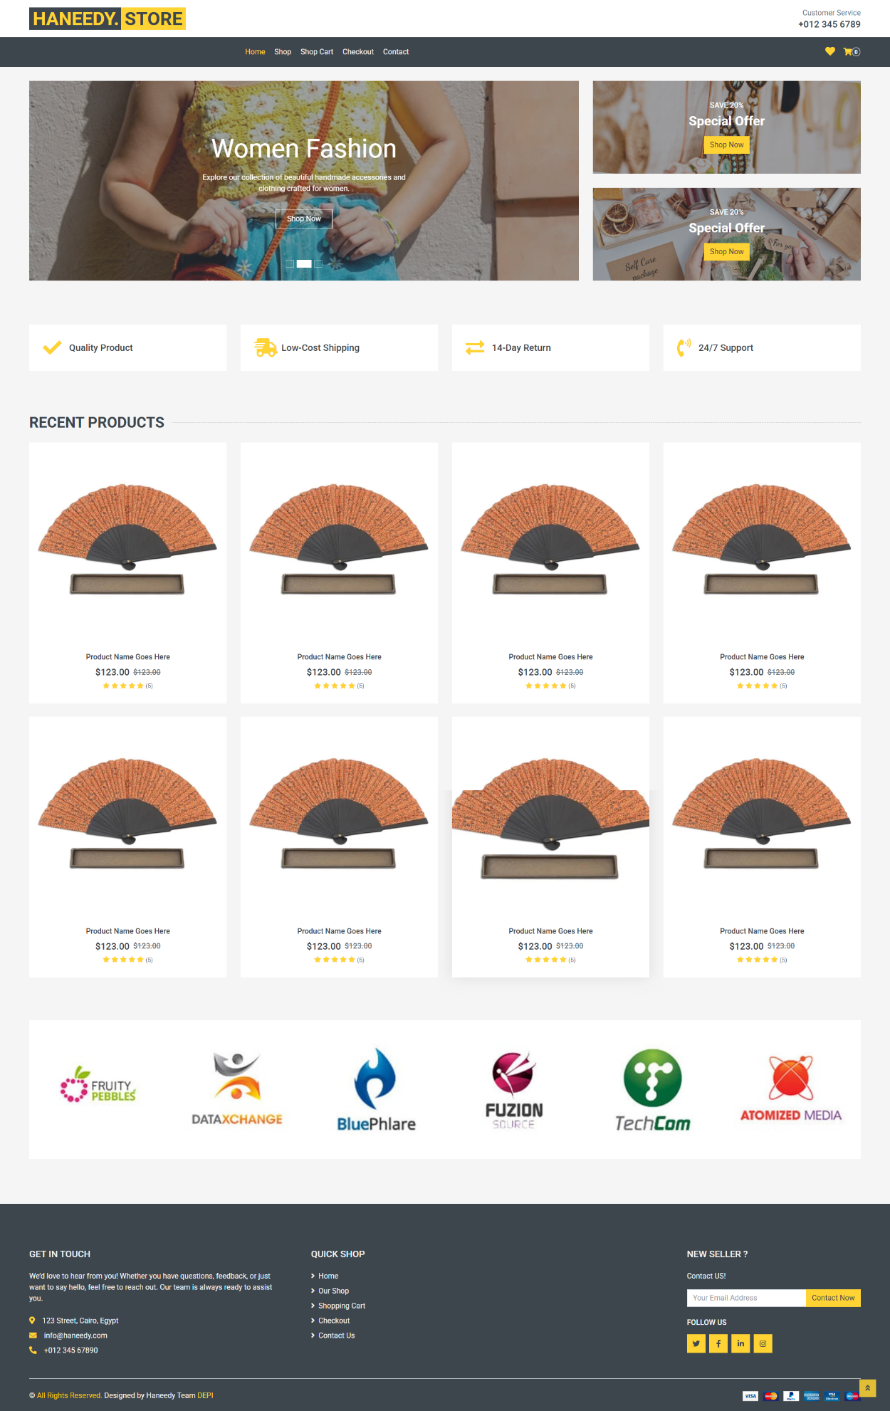
- Shop Page
- 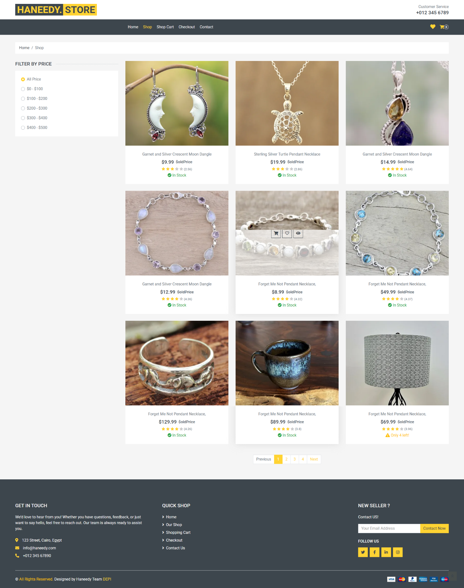
- Single Product Page
- Cart Page
- Wishlist Page
- 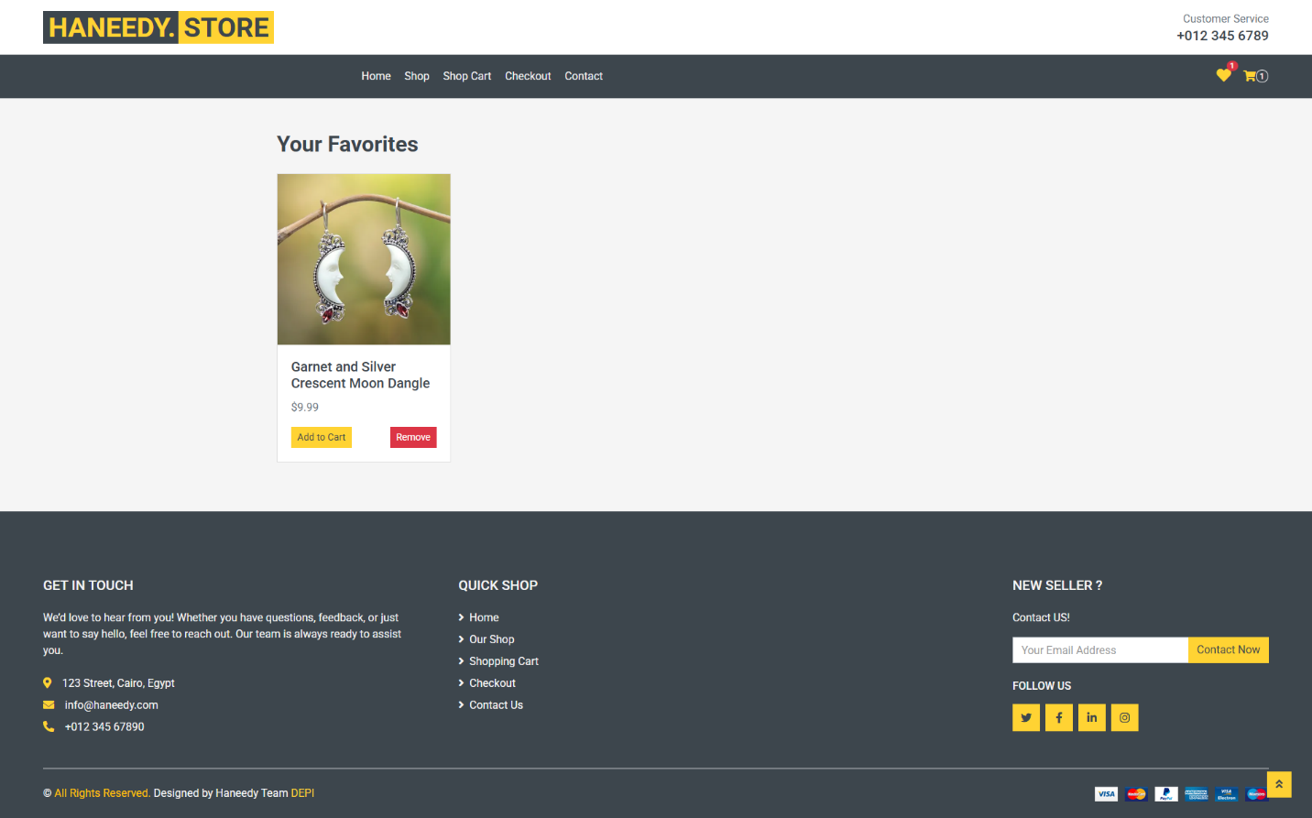
- Checkout Page
- 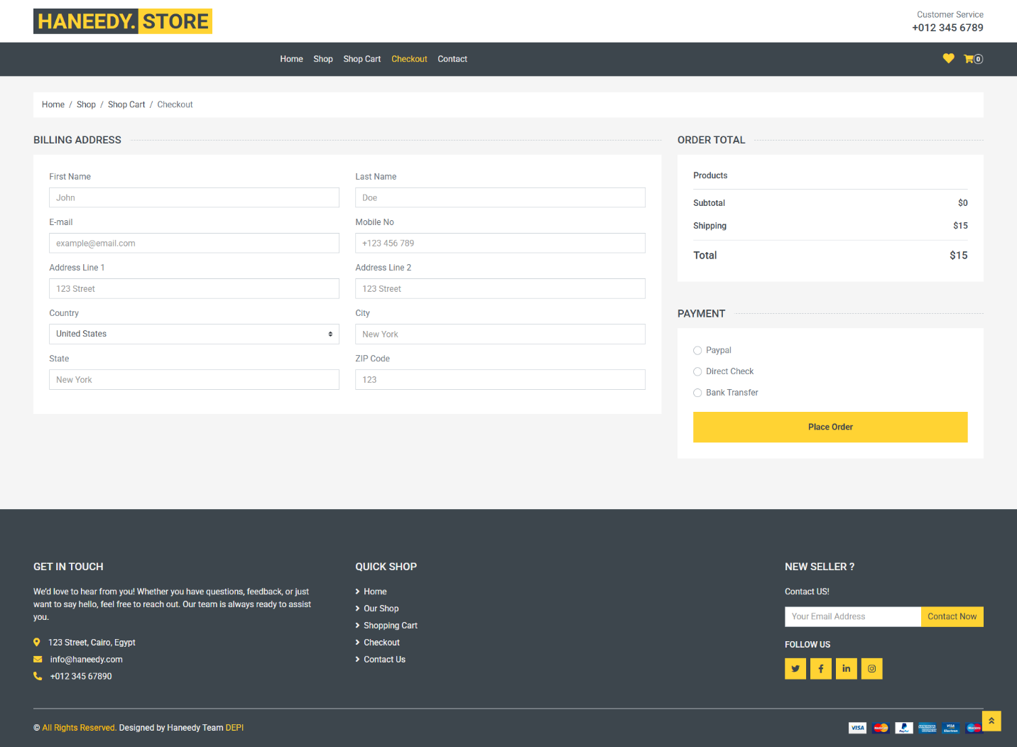

13. Conclusion
This documentation explains the structure, functionality, and components of Haneedy E-Commerce Website. It serves as a guide for developers to understand, maintain, and enhance the application.

